Employee Management System SQL Exercises
Database Schema
The following schema defines the structure for an Employee Management System:
Departments Table
CREATE TABLE Departments (
DepartmentID INT PRIMARY KEY,
DepartmentName VARCHAR(100)
);
Employees Table
CREATE TABLE Employees (
EmployeeID INT PRIMARY KEY,
FirstName VARCHAR(50),
LastName VARCHAR(50),
DepartmentID INT FOREIGN KEY REFERENCES Departments(DepartmentID),
Salary DECIMAL(10,2),
JoinDate DATE
);
Sample Data
The following sample data can be used for testing:
Departments Sample Data
INSERT INTO Departments (DepartmentID, DepartmentName) VALUES
(1, 'HR'),
(2, 'Finance'),
(3, 'IT'),
(4, 'Marketing');
Employees Sample Data
INSERT INTO Employees (EmployeeID, FirstName, LastName, DepartmentID, Salary,
JoinDate) VALUES
(1, 'John', 'Doe', 1, 5000.00, '2020-01-15'),
(2, 'Jane', 'Smith', 2, 6000.00, '2019-03-22'),(3, 'Michael', 'Johnson', 3, 7000.00, '2018-07-30'),
(4, 'Emily', 'Davis', 4, 5500.00, '2021-11-05');

Exercises

Exercise 1: Create a Stored Procedure
Goal: Create a stored procedure to retrieve employee details by department.
Steps:
1. Define the stored procedure with a parameter for DepartmentID.
2. Write the SQL query to select employee details based on the DepartmentID.
3. Create a stored procedure named `sp_InsertEmployee` with the following code:
CREATE PROCEDURE sp_InsertEmployee
@FirstName VARCHAR(50),
@LastName VARCHAR(50),
@DepartmentID INT,
@Salary DECIMAL(10,2),
@JoinDate DATE
AS
BEGIN
INSERT INTO Employees (FirstName, LastName, DepartmentID, Salary, JoinDate)
VALUES (@FirstName, @LastName, @DepartmentID, @Salary, @JoinDate);
END;

CODE:

-- Drop the existing Employees table if it exists
DROP TABLE IF EXISTS Employees;

-- Create Departments Table
CREATE TABLE Departments (
DepartmentID INT PRIMARY KEY,
DepartmentName VARCHAR(100)
);
-- Create Employees Table with EmployeeID as an Identity Column
CREATE TABLE Employees (
EmployeeID INT IDENTITY(1,1) PRIMARY KEY,
FirstName VARCHAR(50),
LastName VARCHAR(50),
DepartmentID INT,
Salary DECIMAL(10,2),
JoinDate DATE,
FOREIGN KEY (DepartmentID) REFERENCES Departments(DepartmentID)
);
-- Insert Sample Data into Departments
INSERT INTO Departments (DepartmentID, DepartmentName) VALUES
(1, 'HR'),
(2, 'Finance'),
(3, 'IT'),
(4, 'Marketing');
-- Insert Sample Data into Employees
INSERT INTO Employees (FirstName, LastName, DepartmentID, Salary, JoinDate) VALUES
('John', 'Doe', 1, 5000.00, '2020-01-15'),
('Jane', 'Smith', 2, 6000.00, '2019-03-22'),
('Michael', 'Johnson', 3, 7000.00, '2018-07-30'),
('Emily', 'Davis', 4, 5500.00, '2021-11-05');
-- Create Stored Procedure to Retrieve Employee Details by Department
GO
CREATE PROCEDURE sp_GetEmployeesByDepartment
@DepartmentID INT
AS
BEGIN
SELECT
EmployeeID,
FirstName,
LastName,
Salary,
JoinDate
FROM
Employees
WHERE
DepartmentID = @DepartmentID;
END;
GO
-- Create Stored Procedure to Insert a New Employee
GO
CREATE PROCEDURE sp_InsertEmployee
@FirstName VARCHAR(50),
@LastName VARCHAR(50),
@DepartmentID INT,
@Salary DECIMAL(10,2),
@JoinDate DATE
AS
BEGIN
INSERT INTO Employees (FirstName, LastName, DepartmentID, Salary, JoinDate)
VALUES (@FirstName, @LastName, @DepartmentID, @Salary, @JoinDate);
END;
GO
-- Example of how to execute the stored procedure to retrieve employees by department
EXEC sp_GetEmployeesByDepartment @DepartmentID = 1;
-- Example of how to execute the stored procedure to insert a new employee
EXEC sp_InsertEmployee @FirstName = 'Alice', @LastName = 'Brown', @DepartmentID = 2, @Salary = 6500.00, @JoinDate = '2023-05-10';
-- After inserting a new employee, you can retrieve the employees again to see the updated list
EXEC sp_GetEmployeesByDepartment @DepartmentID = 2;

OUTPUT:
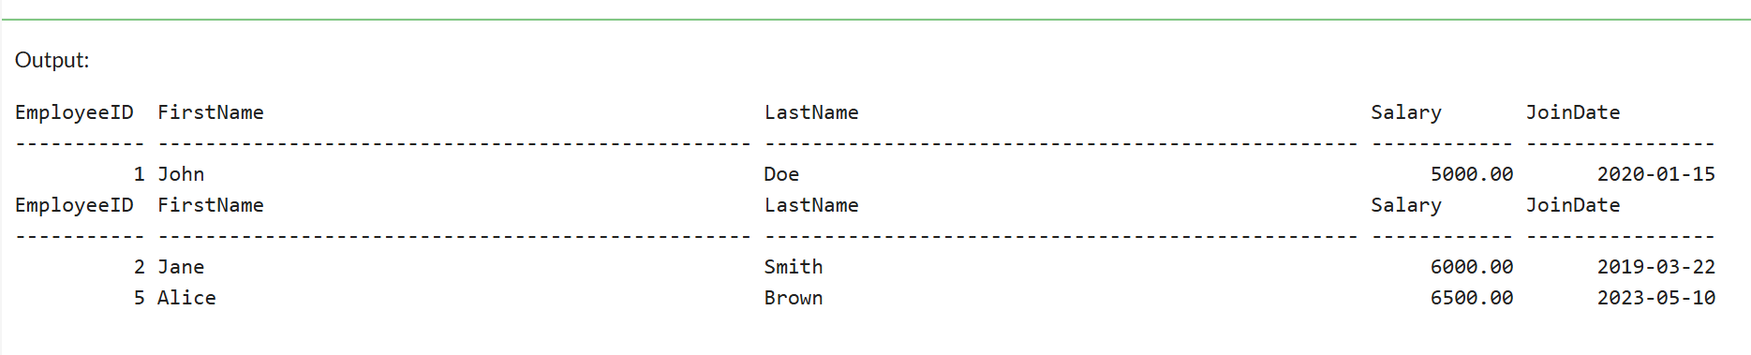

Exercise 4: Execute a Stored Procedure
Goal: Execute the stored procedure to retrieve employee details for a specific department.
Steps:
1. Write the SQL command to execute the stored procedure with a DepartmentID
parameter.
2. Execute the command and review the results.

CODE:

-- Drop the existing Employees table if it exists
DROP TABLE IF EXISTS Employees;

-- Create Departments Table
CREATE TABLE Departments (
DepartmentID INT PRIMARY KEY,
DepartmentName VARCHAR(100)
);
-- Create Employees Table with EmployeeID as an Identity Column
CREATE TABLE Employees (
EmployeeID INT IDENTITY(1,1) PRIMARY KEY,
FirstName VARCHAR(50),
LastName VARCHAR(50),
DepartmentID INT,
Salary DECIMAL(10,2),
JoinDate DATE,
FOREIGN KEY (DepartmentID) REFERENCES Departments(DepartmentID)
);
-- Insert Sample Data into Departments
INSERT INTO Departments (DepartmentID, DepartmentName) VALUES
(1, 'HR'),
(2, 'Finance'),
(3, 'IT'),
(4, 'Marketing');
-- Insert Sample Data into Employees
INSERT INTO Employees (FirstName, LastName, DepartmentID, Salary, JoinDate) VALUES
('John', 'Doe', 1, 5000.00, '2020-01-15'),
('Jane', 'Smith', 2, 6000.00, '2019-03-22'),
('Michael', 'Johnson', 3, 7000.00, '2018-07-30'),
('Emily', 'Davis', 4, 5500.00, '2021-11-05');

-- Create Stored Procedure to Retrieve Employee Details by Department
GO
CREATE PROCEDURE sp_GetEmployeesByDepartment
@DepartmentID INT
AS
BEGIN
SELECT
EmployeeID,
FirstName,
LastName,
Salary,
JoinDate
FROM
Employees
WHERE
DepartmentID = @DepartmentID;
END;
GO
-- Execute the stored procedure to retrieve employees from the HR department (DepartmentID = 1)
EXEC sp_GetEmployeesByDepartment @DepartmentID = 1;

OUTPUT:

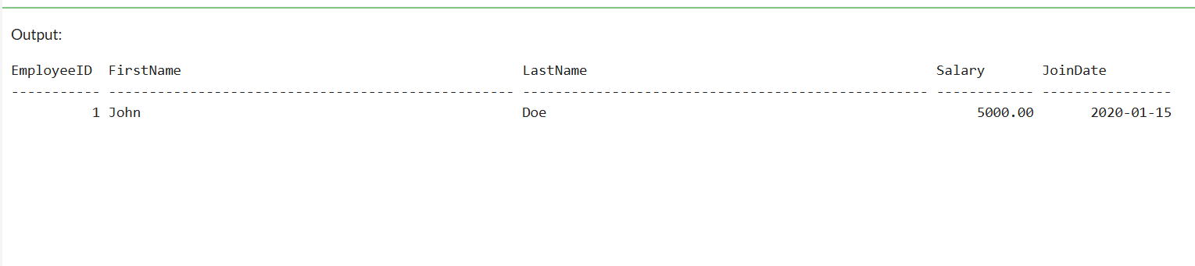

Exercise 5: Return Data from a Stored Procedure
Goal: Create a stored procedure that returns the total number of employees in a
department.
Steps:
1. Define the stored procedure with a parameter for DepartmentID.
2. Write the SQL query to count the number of employees in the specified department.
3. Save the stored procedure by executing the Stored procedure content.

CODE:

-- Drop the existing Employees table if it exists
DROP TABLE IF EXISTS Employees;

-- Create Departments Table
CREATE TABLE Departments (
DepartmentID INT PRIMARY KEY,
DepartmentName VARCHAR(100)
);
-- Create Employees Table with EmployeeID as an Identity Column
CREATE TABLE Employees (
EmployeeID INT IDENTITY(1,1) PRIMARY KEY,
FirstName VARCHAR(50),
LastName VARCHAR(50),
DepartmentID INT,
Salary DECIMAL(10,2),
JoinDate DATE,
FOREIGN KEY (DepartmentID) REFERENCES Departments(DepartmentID)
);

-- Insert Sample Data into Departments
INSERT INTO Departments (DepartmentID, DepartmentName) VALUES
(1, 'HR'),
(2, 'Finance'),
(3, 'IT'),
(4, 'Marketing');
-- Insert Sample Data into Employees
INSERT INTO Employees (FirstName, LastName, DepartmentID, Salary, JoinDate) VALUES
('John', 'Doe', 1, 5000.00, '2020-01-15'),
('Jane', 'Smith', 2, 6000.00, '2019-03-22'),
('Michael', 'Johnson', 3, 7000.00, '2018-07-30'),
('Emily', 'Davis', 4, 5500.00, '2021-11-05');
-- Create Stored Procedure to Return Total Number of Employees in a Department
GO
CREATE PROCEDURE sp_GetTotalEmployeesInDepartment
@DepartmentID INT
AS
BEGIN
SELECT COUNT(*) AS TotalEmployees
FROM Employees
WHERE DepartmentID = @DepartmentID;
END;
GO
-- Example of how to execute the stored procedure to get the total number of employees in the HR department
EXEC sp_GetTotalEmployeesInDepartment @DepartmentID = 1;

OUTPUT:

